WE NEED YOUR HELP!
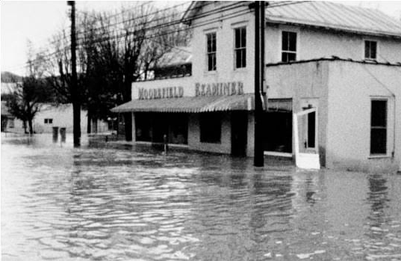
The Region 8 PDC is updating the regional Hazard Mitigation Plan which identifies natural hazards that negatively impact the region like the horrible Election Day flood of 1985. Please take 5 minutes to complete the short survey and give us your thoughts on natural hazards within the region. There are no right or wrong answers and all responses are anonymous. Utilize the QR Code or link below to access the survey.
November 5, 1985 Election Day Flood
Thank you for your participation!
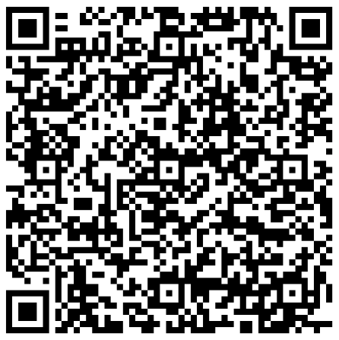

Public Survey Link: https://forms.gle/Y26owJbFLpvbWiKF7

